IP Configuration Details
Command: ipconfig
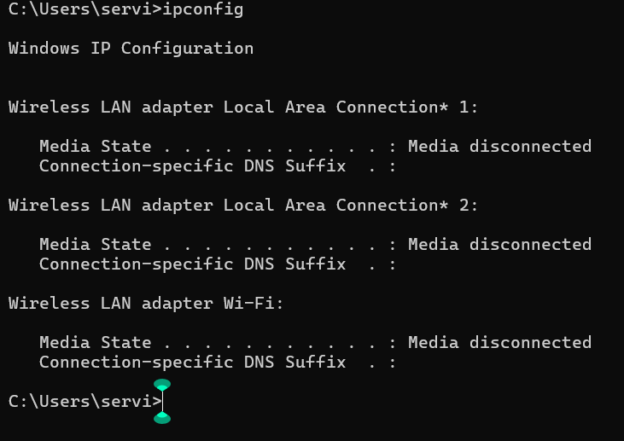
Command: ipconfig/all
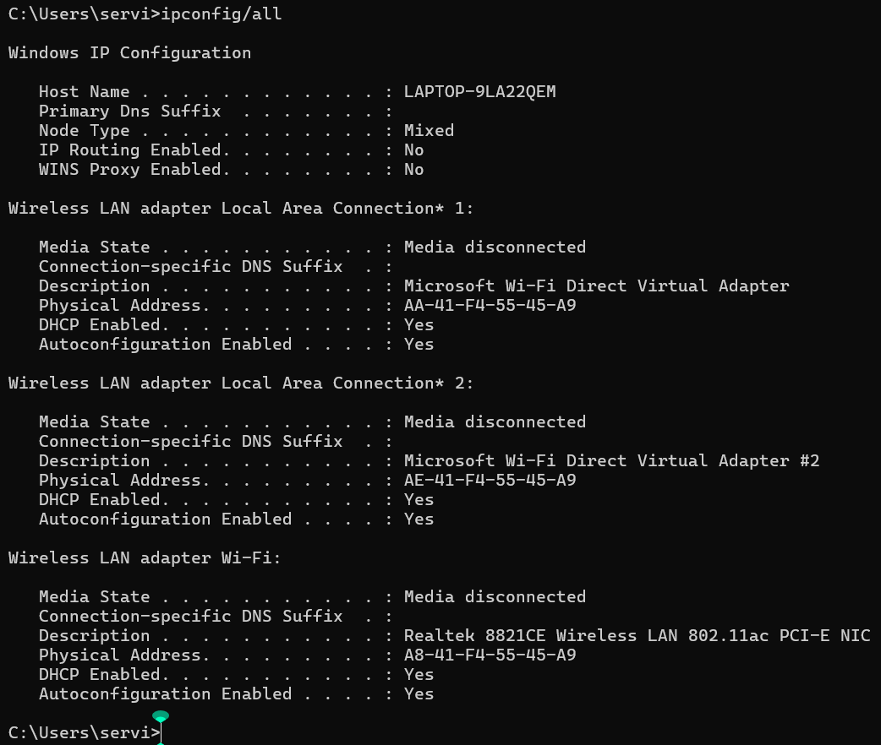

Connected Devices:
Command used:
- arp -a
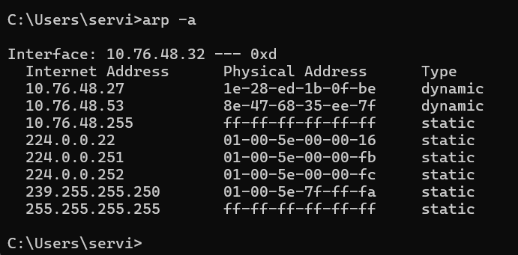
Internet Connectivity Statues
Commands Used:
- ipconfig: Identify the IP address of the connected device which is my smart phone.
- ping: Check the connectivity of the network.
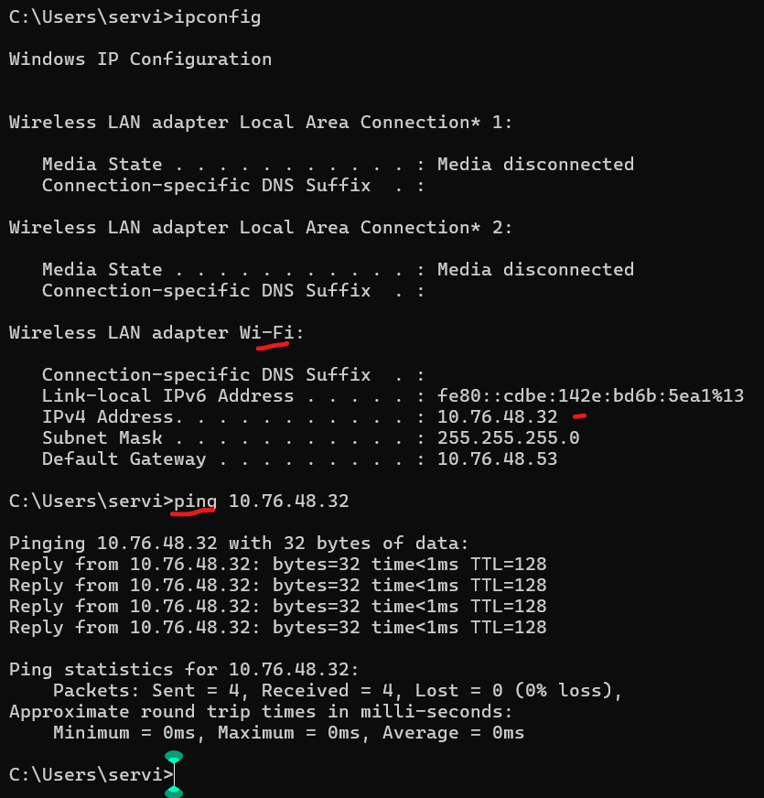
Active Network Connections
Command Used:
- ncpa.cpl
Note: Currently my device does not connect to a network. Therefore, the folder is empty.
